Machrihanish Seabird Observatory
Established 1993
25th Anniversary - 11th September 2018
September Report 2018
Compiled by Eddie Maguire – www.msbowarden@gmail.com
Mobile – 07895 952640
Website – www.machrihanishbirdobservatory.org.uk

Photo of the Month...
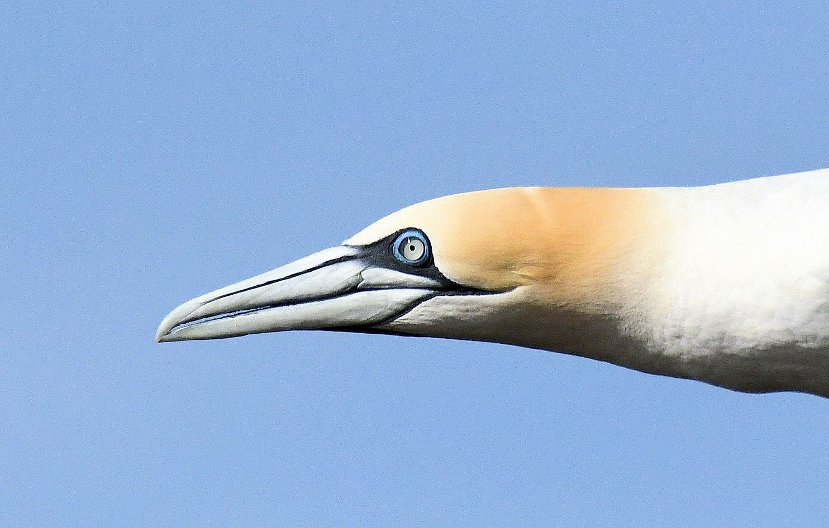

Northern Gannet – a fly-by adult ‘on the doostep’ MSBO 12th September

Introduction...
The September Report includes significant visible migration counts (many from photographs) of fly-by waders, records of other species and summary photographs (19) along with sightings from around Kintyre by a few contributors.

Throughout September, daily surveillance of Northern Gannets crossing 8km overland to the west from Campbeltown Harbour (Clyde waters) to Machrihanish Bay (Atlantic) was sustained. This unique MSBO ongoing project will continue through to at least mid-October.

Arran Natural History Society and Argyll Bird Club visited MSBO during the month; see notes by Jim Cassels and Eddie Maguire at end of this report.

List of Selected Species...

Whooper Swan
Stewarton; 7 on 29th (Argyll Bird Club Outing).
The first local record this autumn.

Pink-footed Goose
Flock ca. 80 >S on 19th.
The Laggan; 17 >E at Strath on 22nd and 12 at Bleachfield on 23rd.

Greater Scaup
Flock 12 >S on 15th and 2 >S on 24th.
The first MSBO records this year.

Common Eider
The first male seen in flight after the flightless moult period was on 8th then 4 on 9th.
2017; the first male(s) seen in flight occurred on 6th - 8th September.

Long-tailed Duck
Campbeltown Loch; a fem/ imm-type on 29th (Argyll Bird Club Outing).
This is the first local record this autumn.

Common Scoter
A male >S on 9th, 2 males >S on 14th and a tight group of 7 >S on 15th appeared to be all males. Two (male and female) >S on 29th.

Red-throated Diver
Southerly passage totals (adults); one on 1st, 5 on 7th, 14 on 10th, 6 on 12th, 3 on 13th, 33 adults / 6hrs on 14th ( largest loose group was 6). More adults followed with 8 on 15th, 14 on 16th, 3 on 17th, none 18th – 20th, 17 / 6hrs on 21st including the first juvenile, a juvenile on 23rd, none 24th - 26th, 12 adults on 27th, 6 adults on 29th and 3 adults on 30th.
Summary of September passage at MSBO; a total of 125 >S on 12 dates.
This September exodus south through Argyll has been well documented at MSBO and Frenchman’s Rocks, Islay in the past.

Great Northern Diver
The first of the autumn, an immature (2CY), >S on 30th.

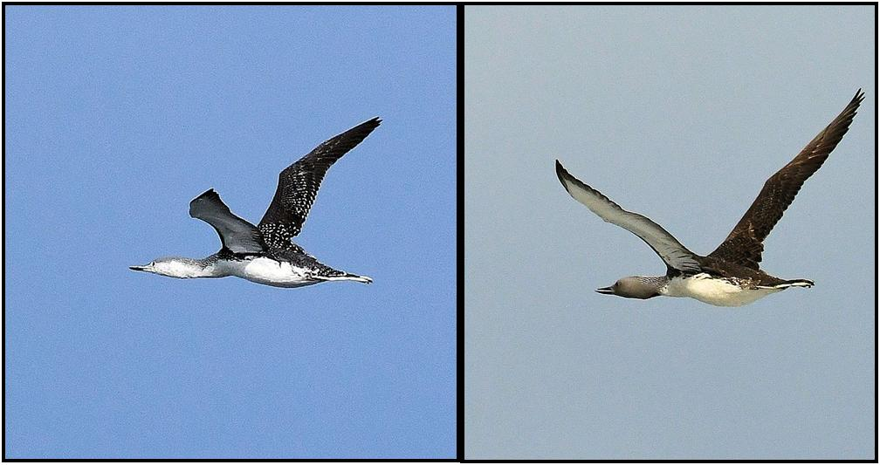

Red-throated Divers – on passage off MSBO 21st September / juvenile (left) & adult

Manx Shearwater
The first real movement of the year was only ca. 400 >S / 3hrs during a WSW gale event on 19th.
Another poor September showing.

Leach’s Petrel
The first bird seen this year appeared well offshore >S on 12th in a WNW f5 with light squalls (Eddie Maguire / Charlie Robertson). A total of 21 >S / 3hrs from 09:25 on 16th in a WSW f5 -6 / squalls (Eddie Maguire / Paul Evans).

Northern Gannet
Southerly passage of juveniles; the first appeared on 12th in a WNW f5. One on 14th, 3 on 19th, 2 on 26th, 2 on 27th, 9 on 29th and 2 on 30th.
Summary; a total of 20 juveniles >S on 7 dates from 12th.

See also Northern Gannets Crossing Kintyre at the end of this report.
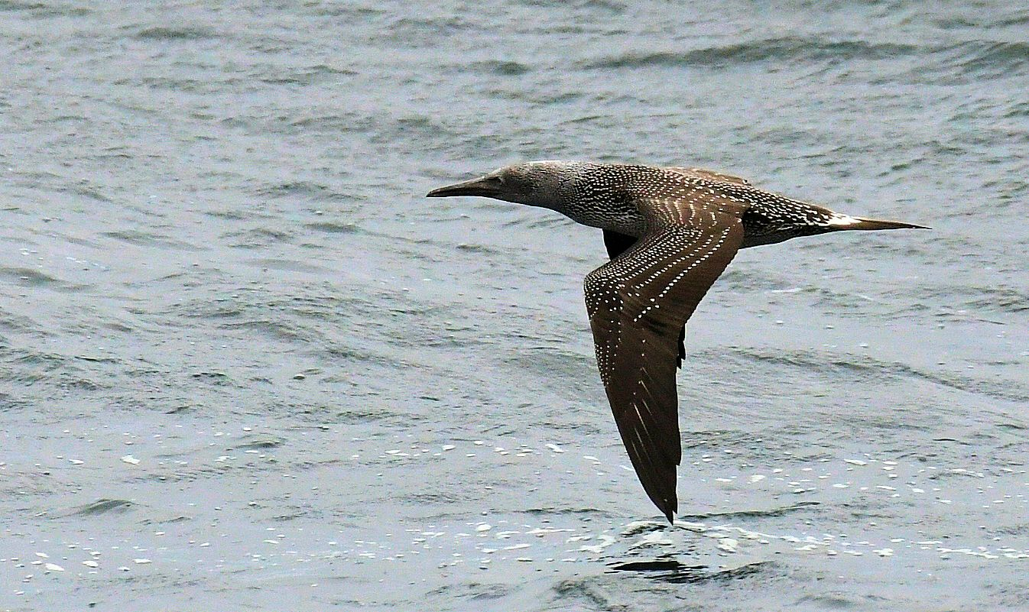
Northern Gannet – juvenile on passage off MSBO 29th September

Hen Harrier
Homeston; 2 brown-types on 1st (Brian Morton pers. comm.).

Eurasian Sparrowhawk
Sightings of singles on 4th, 9th, 10th, 12th, 16th and 20th.

Peregrine Falcon
Campbeltown; an adult was loafing on the Lorne and Lowland church early morning on 5th and 6th. On 13th, 20th and 24th, probably the same bird was on the east spire at dusk (19:54, 20:10 and 20:02 hrs) and perhaps went to roost on the broad ledge below.

Eurasian Oystercatcher
Southerly passage totals; 20 on 5th, 16 on 12th and 10 on 16th.

Golden Plover
Three >S on 12th. Two >S on 30th.

Common Ringed Plover
Eight >S on 12th. Seven >S on 30th.

Whimbrel
Southerly passage totals; Singles on 5th and 14th.

Eurasian Curlew
Southerly passage totals; 11 on 1st, 6 on 4th, 14 on 5th, 5 on 8th, 2 on 10th, 9 on 12th.
Summary of September passage at MSBO; a total of 47 >S on 6 dates.

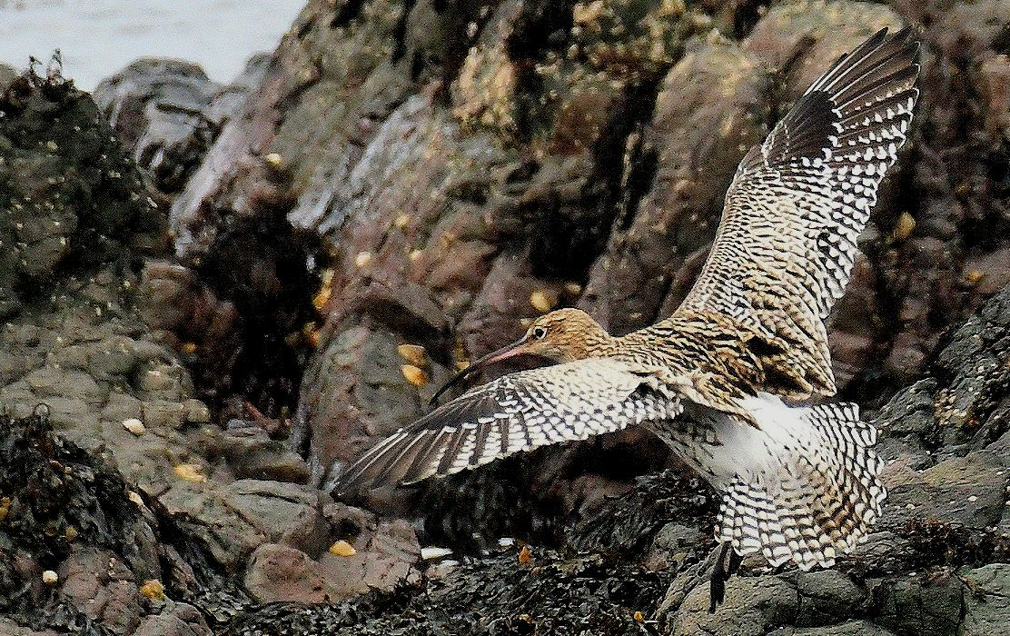
Curlew – MSBO 28th September

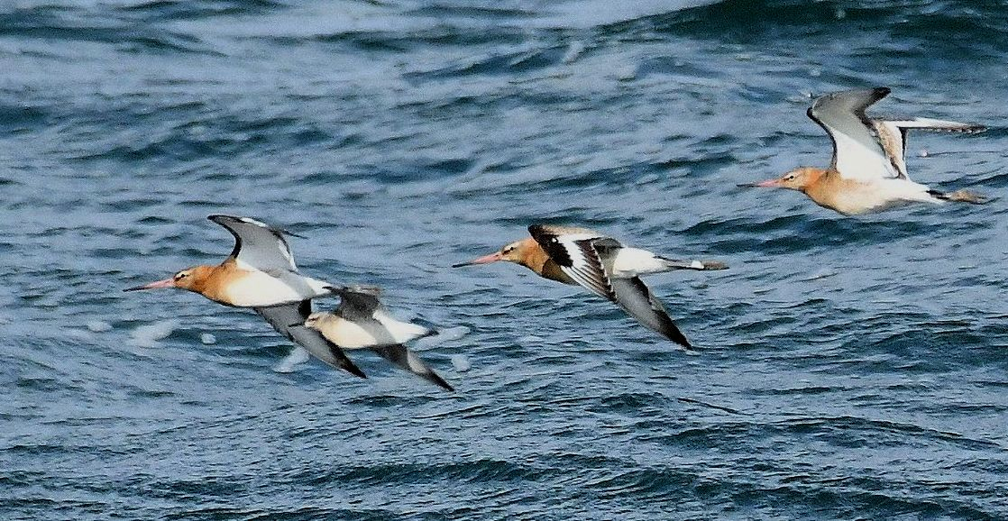
Black-tailed Godwits & Red Knot – on passage MSBO 12th September

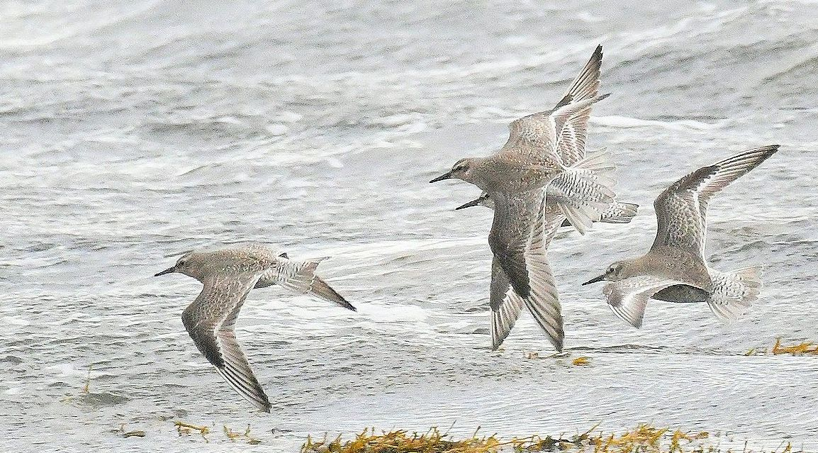
Red Knot – on passage MSBO 11th September

Red Knot
Southerly passage totals; 2 on 10th, 5 on 11th, 9 on 12th, one on 13th, flock 16 on 14th, flock 9 on 18th and one on 21st.
Summary of September passage at MSBO; a total of 43 >S on 7 dates.

Bar-tailed Godwit
One >S on 3rd.

Black-tailed Godwit
Flocks 12 >S on 12th and 8 >S on 14th.

Ruddy Turnstone
Southerly passage totals; two on 3rd, one was off-passage briefly then >S on 7th, 18 on 11th, 8 on 12th, one on 15th, 7 on 16th, 2 on 18th and one on 22nd.
Summary of September passage at MSBO; a total of 40 >S on 8 dates.

Sanderling
Southerly passage totals; 14 >S on 12th, 12 on 14th, 9 on 15th, 42 on 16th, 15 on 18th and 25 on 19th.
Summary of September passage at MSBO; a total of 117 >S on 6 dates.

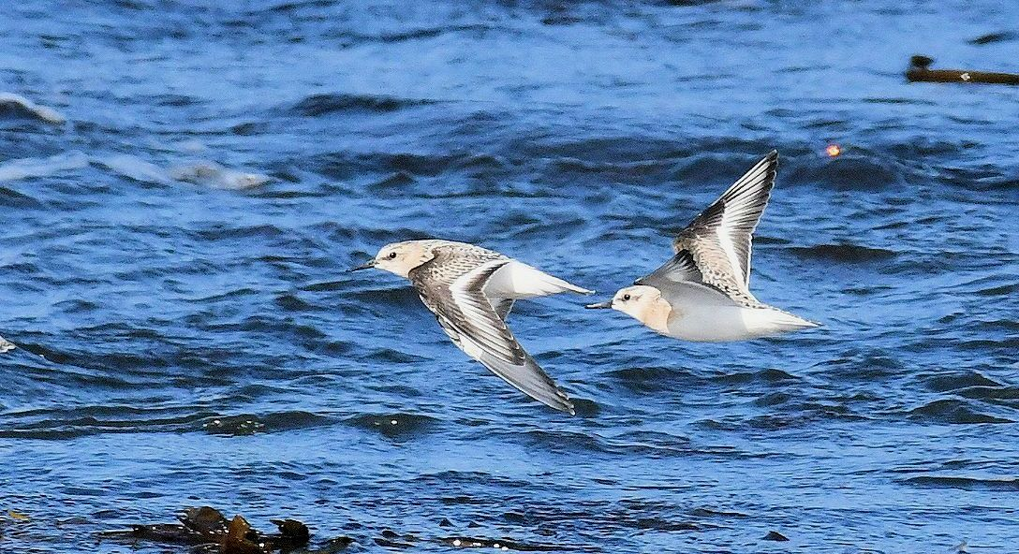
Sanderlings – on passage MSBO 12th September

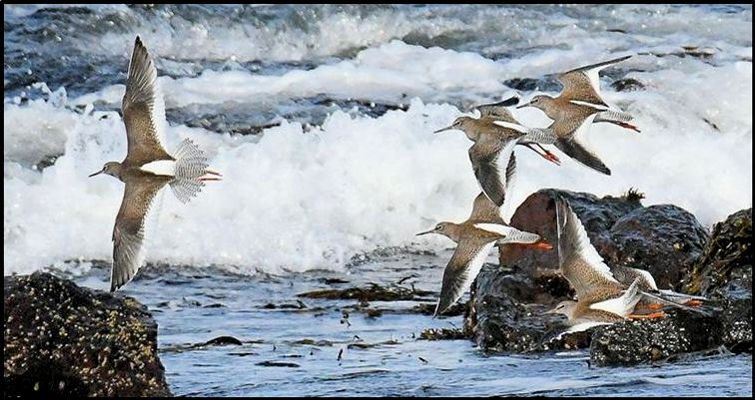
Common Redshanks – on passage MSBO 6th September

Dunlin
Southerly passage totals; 3 on 11th, 30 on 12th, 17 on 16th and one on 27th.

Purple Sandpiper
The first birds of the autumn were 3 >S on 20th and 7 >S on 29th.

Common Sandpiper
A single on 11th was the sole record.

Common Greenshank
Singles >S on 2nd and 9th.
Kennacraig; 3 on 8th (Jim Dickson pers. comm.).

Common Redshank
Southerly passage totals; 6 on 1st, 18 on 2nd, 9 on 4th, two flocks totalling 51 on 6th, 6 on 11th, 10 on 12th, 4 on 13th, 14 on 14th, 11 on 16th and 6 on 20th.
Summary of September passage at MSBO; a total of 135 >S on 10 dates

Autumn passage of waders at MSBO 2018...
From July to September 2018, a total 6,650 waders that included 16 species were logged on migration at MSBO.
Table 1. Monthly / cumulative totals of fly-by waders on passage south at MSBO.

Species | July | Aug | Sept | Species totals
Eurasian Oystercatcher | 489 | 972 | 46 | 1,507
Golden Plover | - | - | 5 | 5
Common Ringed Plover | 138 | 197 | 15 | 350
Whimbrel | 3 | 30 | 2 | 35
Eurasian Curlew | 124 | 179 | 47 | 350
Bar-tailed Godwit | 4 | 11 | 1 | 16
Black-tailed Godwit | 0 | 255 | 20 | 275
Ruddy Turnstone | 4 | 71 | 40 | 115
Red Knot | 12 | 31 | 43 | 86
Ruff | 0 | 2 | 0 | 2
Sanderling | 557 | 688 | 117 | 1,362
Dunlin | 449 | 1,062 | 51 | 1,562
Purple Sandpiper | 0 | 0 | 10 | 10
Common Sandpiper | 191 | 33 | 1 | 225
Common Greenshank | 5 | 7 | 2 | 14
Common Redshank | 227 | 374 | 135 | 736
Grand totals | 2,199 | 3,912 | 519 | 6,650

Great Skua
One >S on 11th. Five singles >S during a WSW gale event on 19th. One >S on 21st.

Arctic Skua
One was photographed >S during a WSW gale event on 19th.
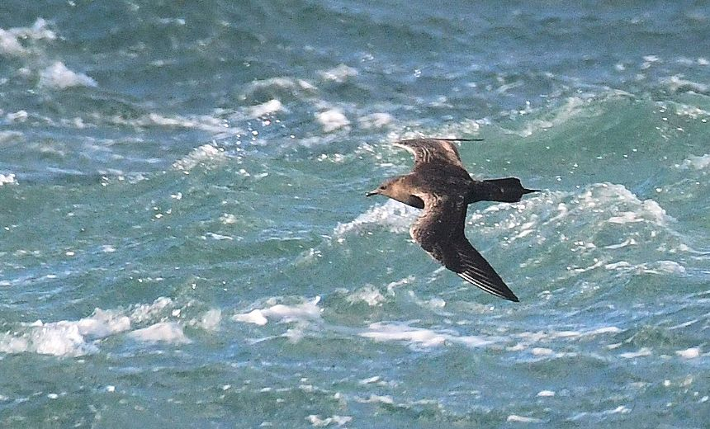
Arctic Skua – on passage MSBO 19th September

Mediterranean Gull
A first-winter (1CY) was very briefly by MSBO then >S on 12th and a first-winter was photographed >S well offshore on 18th.
These are the 5th and 6th MSBO records this year following 2 juveniles in August, an immaculate summer-plumaged adult in June and a 2CY in May.
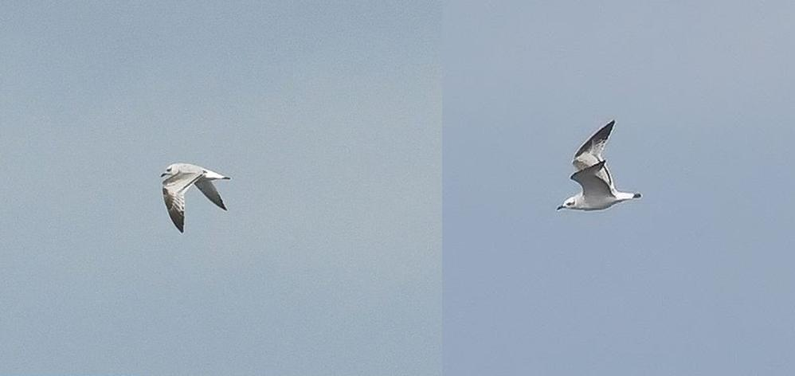
Mediterranean Gull – a first-winter >S off MSBO 18th September

Iceland Gull
The Laggan; a 2CY was at Drumlemble on 29th (Argyll Bird Club Outing).
The first local record this autumn.

Black-legged Kittiwake
The top movement was 370 >S / 8hrs during a WSW gale event on 19th.
A very poor September showing.
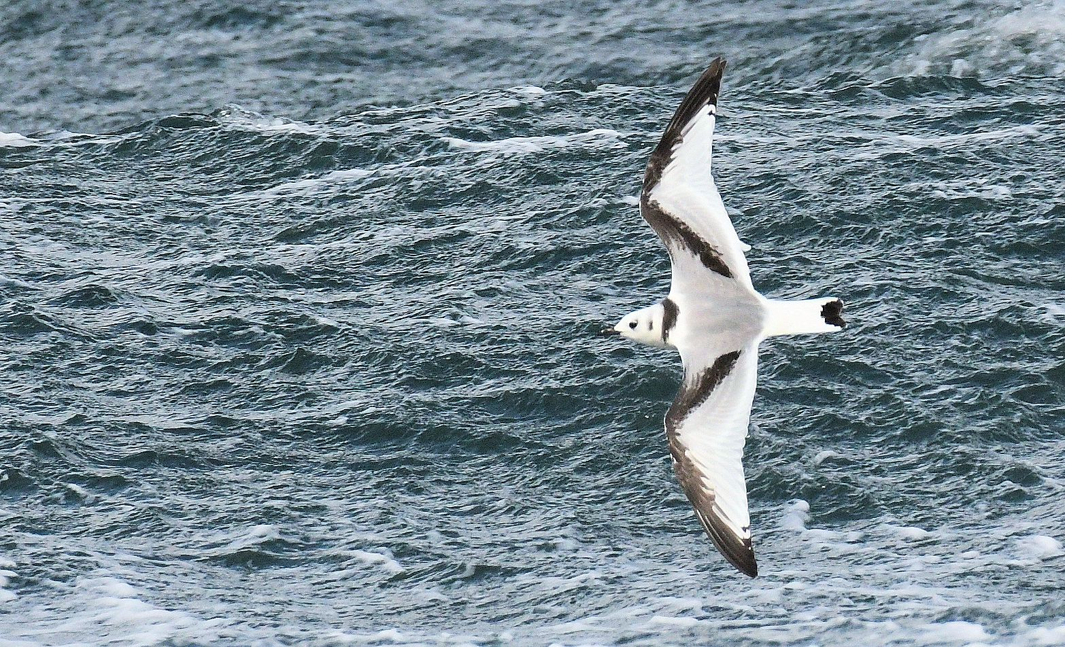
Black-legged Kittiwake – juvenile >S off MSBO 19th September

Sandwich Tern
Adults: singles on 3rd and 10th, 5 on 17th, 4 on 19th (including 2 juveniles) and an adult and a juvenile >S on 21st.

Arctic Tern
A loose flock of 5 first–winter birds >S on 21st.

Eurasian Magpie
Campbeltown; one at Sronvaar Bowling Club on 18th (Alistair Anderson et al).

House Martin
A loose flock of 30 >S over the sea on 20th.

Northern Wheatear
A Greenland-type adult was on the point briefly then >S on 18th.

White Wagtail
Southerly passage totals; 5 on 1st. On 2nd, the turnover of birds around the point was 70+ / 5hrs; singles and small groups (2 – 9) arrived intermittently from the north and rested very briefly on the point before moving on south. There was comparable staggered arrival patterns on passage dates later with 30+ on 3rd and 20+ on 4th. Numbers then tailed off with only 8 on 5th, 3 on 6th, one on 7th, 12 on 8th and 3 on 9th. Another protracted passage occurred on 10th with around 50+ logged >S over 4hrs (SW f3 / light rain). Later there was 17 on 11th, 23 on 12th, none on 13th, 2 on 14th, 7 on 15th, 15 on 16th, none on 17th, 11 on 18th, 4 on 19th, 7 on 20th, 3 on 21st, 5 on 22nd, none on 23rd, 3 on 24th then none 25th- 30th.
Summary of September passage at MSBO; a total of 292 >S on 21 dates.

Meadow Pipit
Light passage along the shore to 9th then ca. 185 >S / 5hrs (light drizzle) on 10th and 70 >S on 12th.
These movements were comparable to the staggered passage arrivals of White Wagtails on the same dates (see previous species).

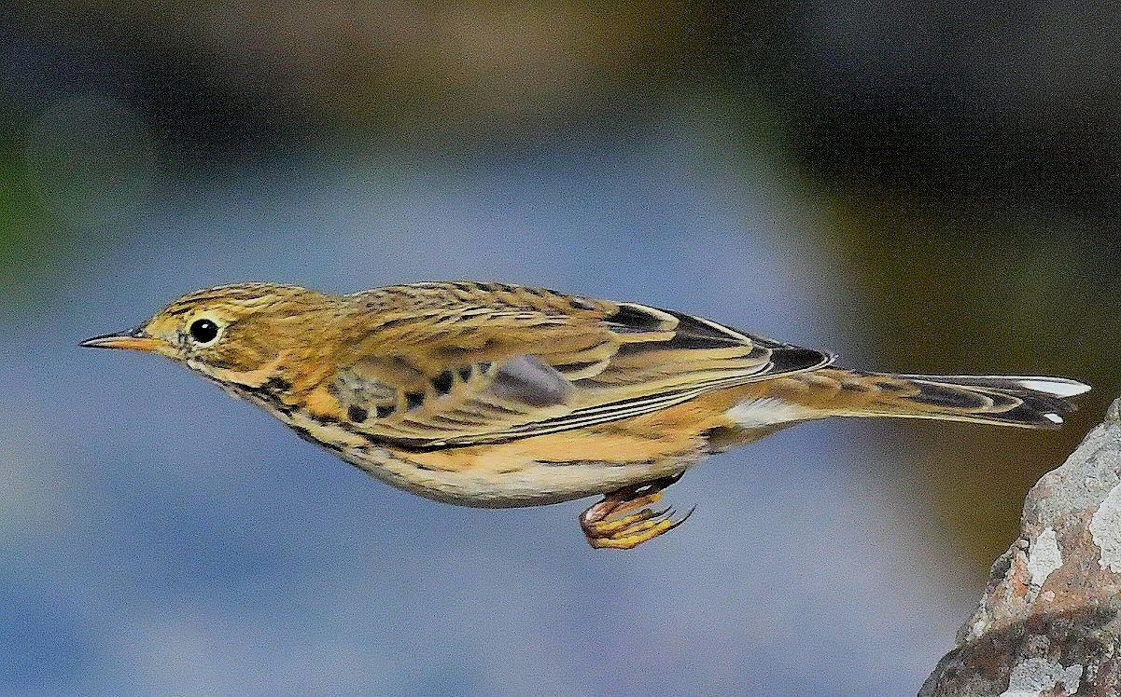
Meadow Pipit – on passage MSBO 12th September

Fieldfare
Dalsmerran (near Southend); The first local record was 200+ >W early am on 28th (Brian Morton pers. comm.).

Twite
Dunaverty (Southend); ca. 50 on 1st (Robert Shaw pers. comm.).
MSBO; one on 5th and one on 24th.

Northern Gannets Crossing Kintyre 2018...

September 2018; a total of 372 adults crossed overland to the west from Campbeltown Loch in SE Kintyre for the Atlantic on 27 / 30 days of observation.
Table 2. Daily totals of adult Gannets flying 8km overland from Campbeltown Harbour (Clyde waters) to Machrihanish Bay (Atlantic) during September along with wind direction/force and departure times of first/last bird.
September | Number  Adults  crossing  overland | Wind  Direction  &  force | Campbeltown  Departure  times of  first / last bird
1st | 19 | Calm | 11:33 – 20:18
2nd | 5 | ESE 3 | 12:15 – 16:21
3rd | 7 | NNW 2 - 3 | 18:42 – 19:15
4th | 10 | Calm - NW 1 | 12:33 – 20:10
5th | 23 | S 1 - 2 | 11:12 – 20:12
6th | 0 | WNW 3 - 4 | -
7th | 11 | WNW 4 - 5 | 14:03 – 15:41
8th | 21 | WNW 2 - 3 | 13:12 – 18:35
9th | 32 | WNW 4 - 5 | 08:50 – 19:05
10th | 13 | SW 3 | 12:37 – 19:37
11th | 18 | W 4 - 5 | 10:45 – 19:52
12th | 16 | WNW 3 - 5 | 09:02 – 18:39
13th | 17 | W 4 | 09:27 – 18:37
14th | 21 | W 4 | 08 :53 – 18:58
15th | 11 | WSW 2 | 11:10 – 19:20
16th | 20 | NW 5 - 6 | 12:05 – 17:03
17th | 2 | S 4 - 5 | 12:43 – 18:23
18th | 7 | WNW 3 | 15:23 – 19:14
19th | 0 | WSW 7 - 9 | –
20th | 0 | SW 2 | –
21st | 5 | NW 4 | 07:40 – 09:00
22nd | 6 | NW 2 - 3 | 13:53 – 18:30
23rd | 15 | NNW 4 - 5 | 07:13 – 18:23
24th | 15 | W 3 | 12:06 – 15:35
25th | 20 | WSW 3 | 10:00 – 19:27
26th | 9 | W 3 | 14:25 – 19:15
27th | 4 | NW 4 - 5 | 10:22 – 15:07
28th | 3 | W 2 | 14:40– 16:50
29th | 25 | WSW 3 - 4 | 11:08 – 16:38
30th | 17 | NW 4 - 5 | 12:59 – 17:05
Total | 372

From March to September 2018 a total of 1,205 adult Gannets crossed overland on 149 / 214 days of surveillance.
Table 3. The numbers of adult Gannets that crossed west over Kintyre during March to October 2017 compared with the 2018 monthly data..
2017 | March | April | May | June | July | Aug | Sept | Oct
Monthly totals | 2 | 23 | 131 | 126 | 274 | 408 | 491 | 6
Cumulative totals | 2 | 25 | 156 | 282 | 556 | 964 | 1,455 | 1,461
No. days of  Observation | 27 | 29 | 22 | 24 | 31 | 24 | 30 | 20
2018 | March | April | May | June | July | Aug | Sept | Oct
Monthly totals | 6 | 45 | 78 | 336 | 121 | 247 | 372
Cumulative totals | 6 | 51 | 129 | 465 | 586 | 833 | 1,205
No. days of  Observation | 31 | 30 | 31 | 30 | 31 | 31 | 30

Gannets crossing 8km overland in South Kintyre

Factfile...
- South Kintyre is the only accredited location in the UK where Gannets routinely cross overland during the breeding season, often in significant numbers, presumably to gain rapid access to foraging grounds.
- Only adults have crossed the low-lying 8km overland route from Campbeltown to Machrihanish Bay and to date, the overland passage is strictly one way – to the west (Clyde > Atlantic).
- Gannets flying to the west over Campbeltown look aerodynamic and are evidently at minimal weight which must obviously be a huge advantage when crossing west over S Kintyre.
- Gannets employ powered flight (sustained flapping) to cross the 8km at around 35 mph and the crossing has been timed on a regular basis at a constant 9 mins.
- After foraging successfully, Gannets are burdened significantly with fish prey, are visibly bloated and evidently at top weight; therefore, it is unlikely that they would attempt to fly overland from Atlantic to Clyde. The return journey to the Ailsa colony from Machrihanish is strictly a marine route via Mull of Kintyre relying heavily on assisted passage by alternating powered flight in concert with dynamic soaring (wave power) to accomplish this.
- There is a substantial increase in the numbers of Gannets that cross west over Kintyre in August and September (see 2017 / 2018 data in Table 3 above); presumably this indicates urgency by breeding adults from almost certainly the Ailsa colony to gain rapid access to foraging grounds in the Atlantic as this period coincides with the final stages of the breeding season when increasing food demands of large chicks reach their peak.
- The record number that crossed overland to the west in a single day was 67 in September 2017.
- The largest flock recorded crossing to the west was 16 in September 2017.
- Wind direction appears to have little / no influence on the numbers that embark on this low-lying overland shortcut to the Atlantic.
- Wind strength does not dissuade crossings either; a high total of 50 birds >W on 19th August 2017 in a WNW force 6.
- Gannets have never been recorded crossing overland to the west during the main winter period November - February

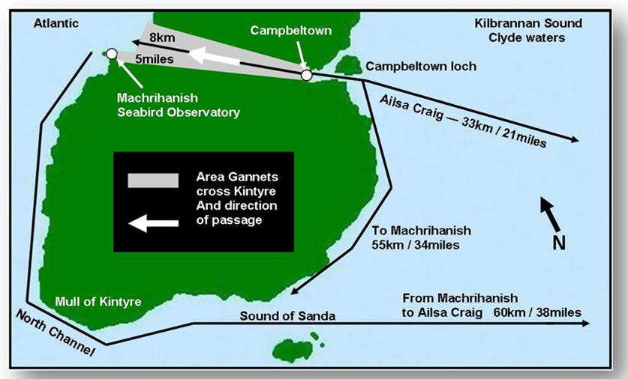

Figure 1. South Kintyre, Argyll showing the westerly overland route (8 km / 9 minute flight) taken by adult Northern Gannets from Campbeltown Loch (Clyde waters) to Machrihanish Bay (Atlantic). Direct marine routes with approximate distance from Campbeltown Loch to Machrihanish and the Ailsa Craig colony are also shown.

A paper by Eddie Maguire / Charlie Robertson relating to studies of monitoring the overland passage of this species during 2017 entitled ‘Northern Gannets crossing overland in South Kintyre, Argyll’ was recently published in the Seabird Group Newsletter (Number 137 / February 2018) and in Argyll Birds Club’s Newsletter The Eider (Number 123 / March 2018).

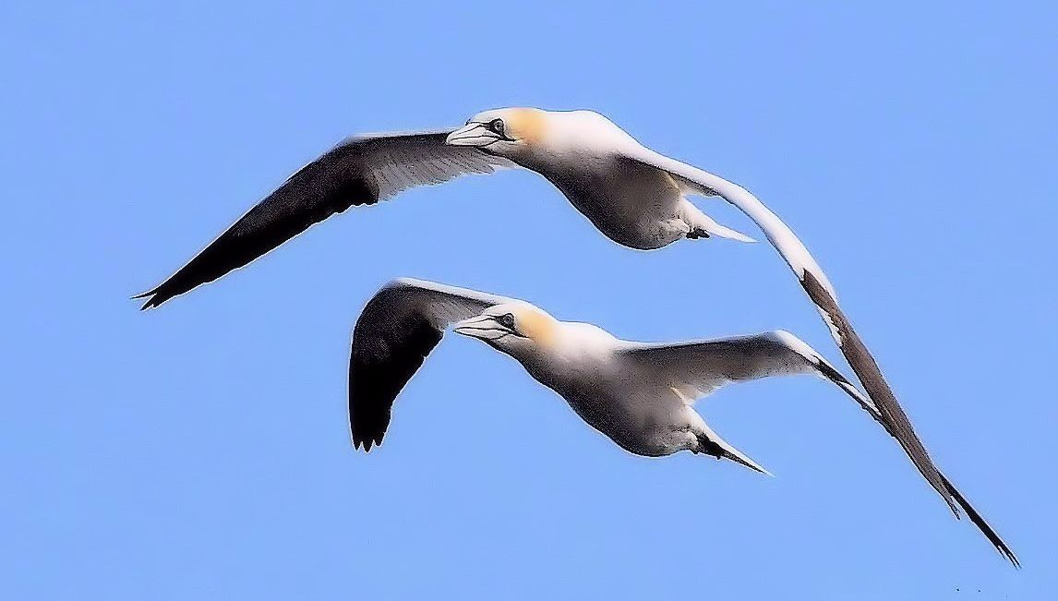
Northern Gannets – adults with full crops and stomachs >S over MSBO 6th September

A few more photos...

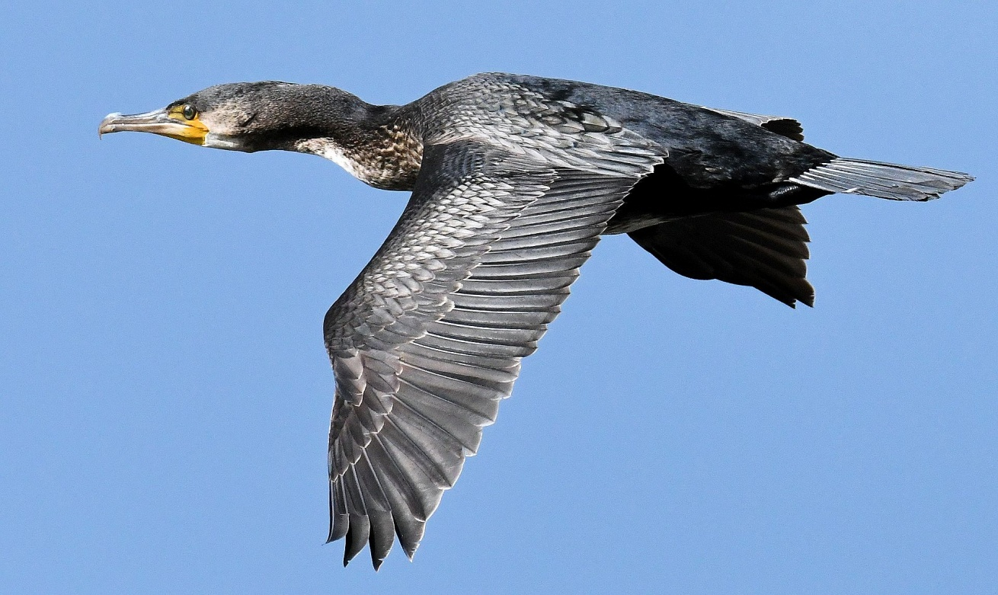
Great Cormorant – MSBO 10th September

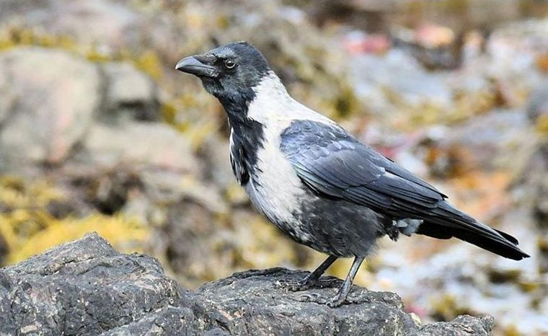
Hybrid Crow Corvus corone x cornix MSBO 14th September

Arran Natural History Society visit Machrihanish Seabird Observatory

Saturday 15th September...
Thirteen members of the Arran Natural History Society enjoyed a visit to Machrihanish Seabird Observatory. This was part of the summer programme of activities for members that included a bird ringing demonstration in Auchenhew Bay in June and a flora walk in Glen Rosa in July.
The Observatory, which has been open for twenty-five years, is about six miles west of Campbeltown on the Atlantic coast on Uisaed Point. Landmarks that can be seen from the Observatory include the top of Davaar Island (8 miles to the east), Altnacarry Lighthouse on Rathlin Island (16 miles to the west / south-west) and the American Monument on the Mull of Oa, Islay (20 miles to the North-West). It is an awe-inspiring promontory to witness visible migration and occasional mass movements of seabirds. Regular Atlantic depressions frequently produce the right conditions to view and record detailed information about ocean-going species and coasting migratory landbirds. Situated at the southern end of Machrihanish Bay, this low promontory juts well out into the Atlantic. The configuration of the coast to the north presents a long leading line from Glenacardoch Point (17km) ensuring – when conditions are right – a steady passage of birds. Throughout autumn, the southerly progression of seabirds, waterfowl, waders and passerines brings many species close to, and often over, the point as they exit from the bay, thus affording superb views.

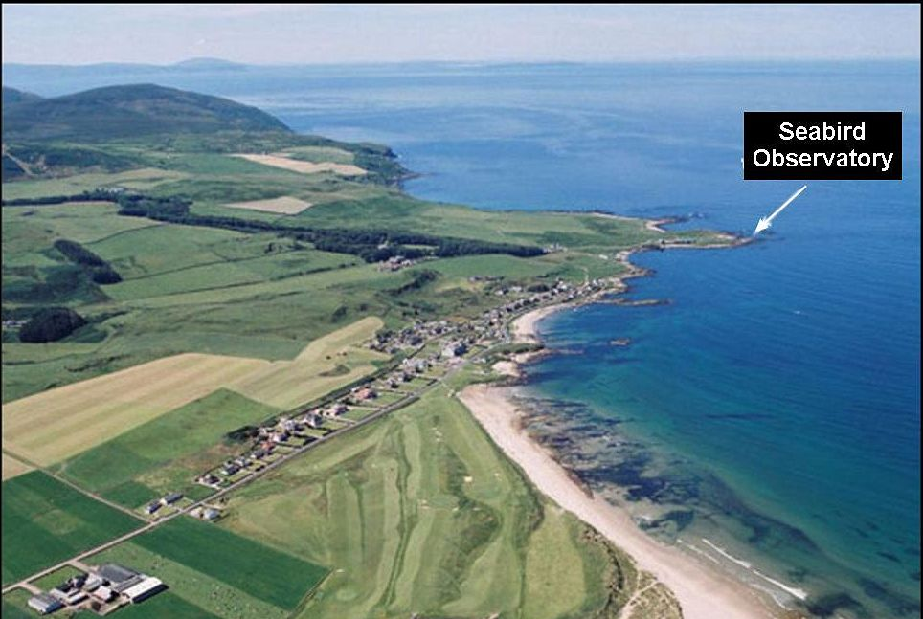
The beautiful village of Machrihanish in SW Kintyre showing location of Observatory
After a welcome and introduction to the Observatory by the warden, Eddie Maguire, the group enjoyed a few rapidly passing hours of wildlife watching that included thirty-two species of bird and a passage of two hundred and eighty-five Gannet. The following day on the Sunday the warden reported a passage of twenty-one Leach's Petrel, a species last recorded on Arran in September 1991. That's bird-watching!
Although the group had missed out on some of the rarer passing seabirds, the verdict on the day from the participants included expressions like "fabulous day out", "great place", "enjoyed all aspects of the day" and "definitely a place to revisit".

For more information on Machrihanish Seabird & Wildlife Observatory visit their website http://www.machrihanishbirdobservatory.org.uk/index.htm.
For more information on the Arran Natural History Society visit FaceBook and Twitter.
Facebook https://en-gb.facebook.com/arranwildlife/
Twitter https://twitter.com/ArranNatHis
Enjoy your birding.
Please send any bird notes with “what, when, where” to me at Kilpatrick Kennels, Kilpatrick, Blackwaterfoot, KA27 8EY, or e mail me at jim@arranbirding.co.uk I look forward to hearing from you. For more information on birding on Arran purchase the “Arran Bird Atlas 2007-2012” as well as the “Arran Bird Report 2017” and visit this website www.arranbirding.co.uk
Jim Cassels

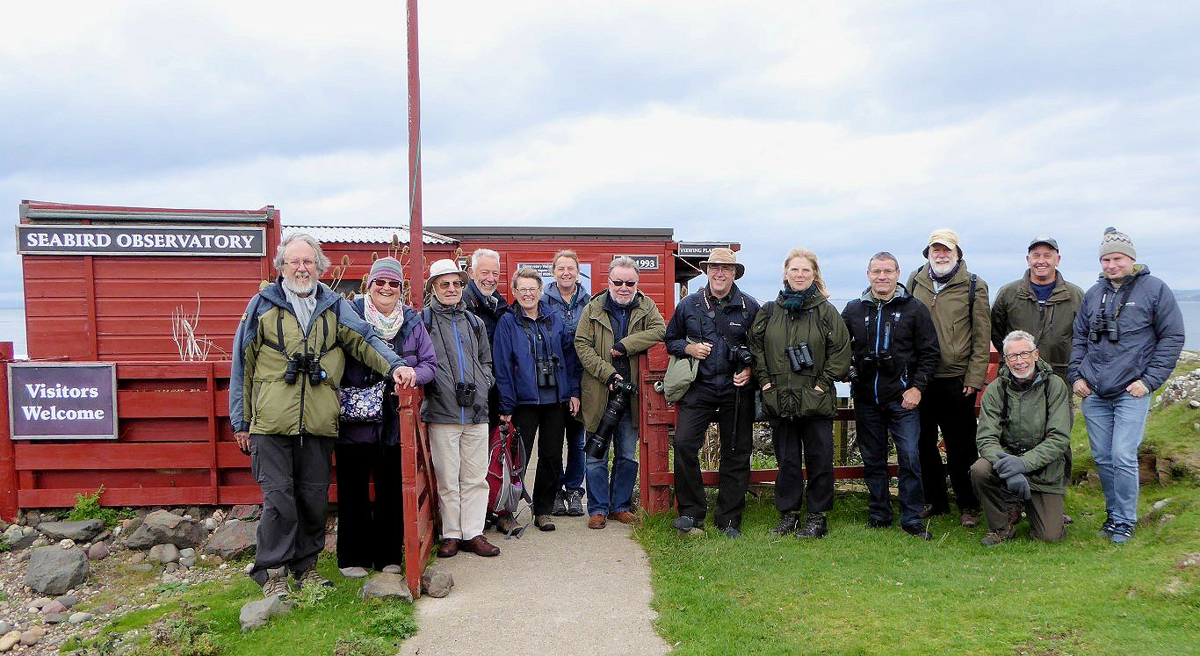
Arran Natural History Society with the warden at MSBO 15th September

Argyll Bird Club visit Machrihanish Seabird Observatory
Saturday 29th September...
A very grey day and not an exceptionally great day for birds, however, several notable local finds for the ABC members just prior to arriving at the Observatory included a Long-tailed duck (fem/imm-type) at Campbeltown Loch, 7 Whooper Swans by Stewarton and a 2CY Iceland Gull by Drumlemble School at The Laggan - a respectable start.
The Bird Clubs introduction on their website declares...
“We are a friendly club for anybody interested in wild birds, living in, or visiting, Argyll, irrespective of their level of knowledge, experience or skill”.
How very true! Eight affable members met Eddie at the MSBO early afternoon where everyone settled in and immediately tucked into lunch.
In the WSW f 3-4 wind seabirds were virtually absent apart from ubiquitous Northern Gannets; regular small flocks with full crops and stomachs passed south en-route for the Ailsa colony. A few less-experienced members were delighted to see their first juvenile (1CY) Gannet. The flight of the juvenile is so much different from that of assertive adults. Juveniles give the impression of being hesitant, insecure and appear to ‘tread softly’ – well they are leaning how to fly and cope with extremes of Atlantic weather systems at the same time! A total of nine youngsters were logged passing south on the day bringing the months total for this age category to 18 on 6 dates from 12th.
A small group of Red-breasted Merganser, 2 Wigeon and 2 Common Scoter all >S was the best of the rest.
A full account of this ABC visit to MSBO will appear in the December “Eider”.

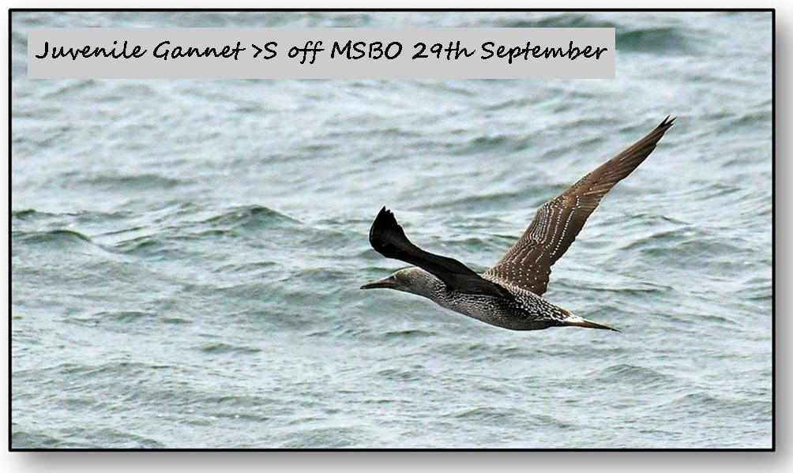
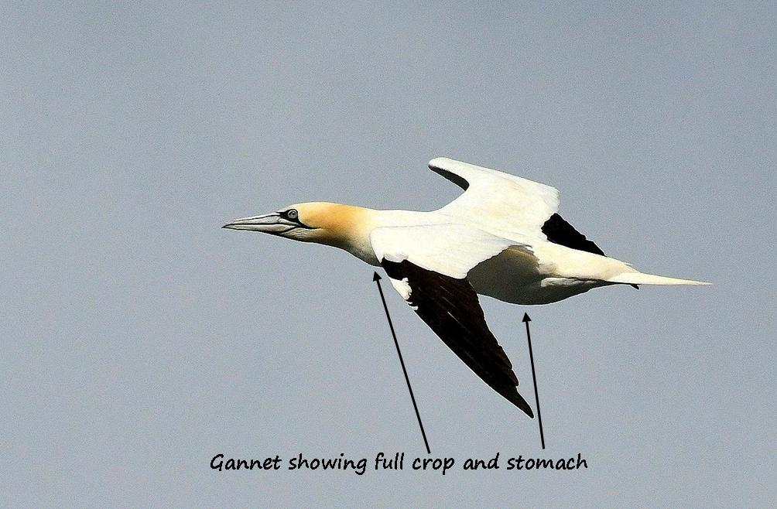
29th September

Ends

