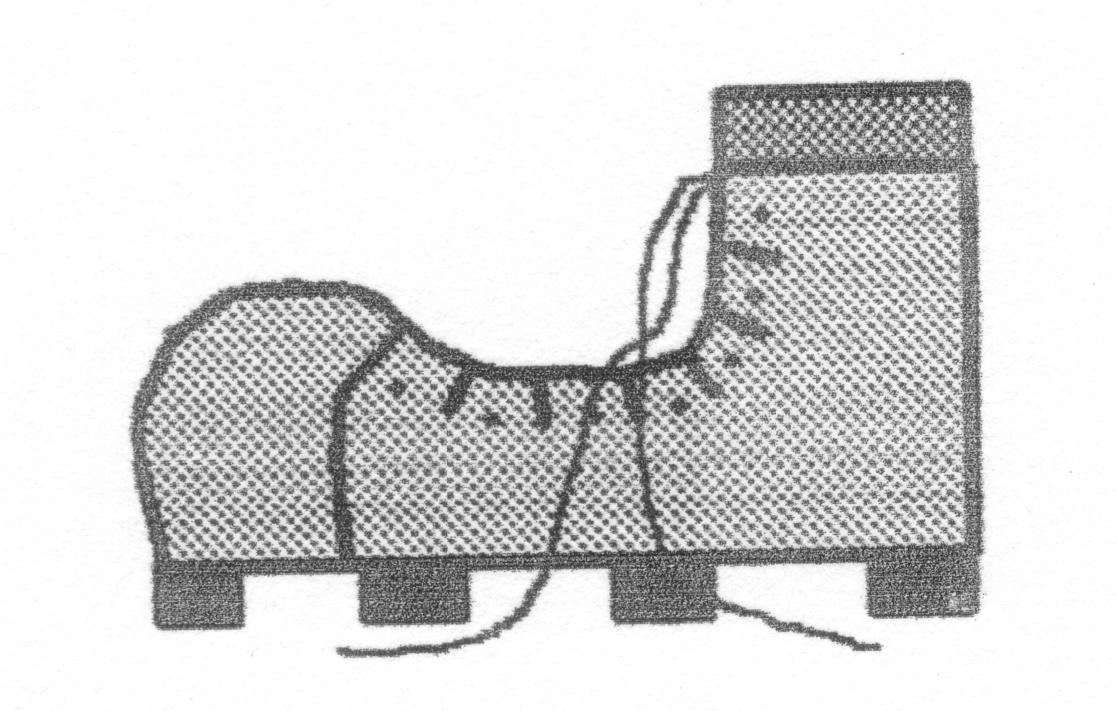
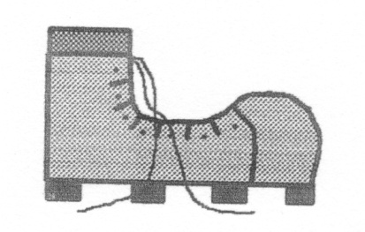
LAKES TRIP WITH RICHARD

April 2019

Saturday 13

I took the first driving stint and we lunched half way at The Boat Inn on the river at Spotborough, just west of Doncaster (where we’ve previously had lunch on our trips to The Lakes with Graham & John). Richard took over driving (as I’d had my pint!) and we arrived at the accommodation – a pleasant two-bedroomed self-catering bungalow in a quiet residential suburb south-east of Keswick town centre.

Sunday 14: Walla Crag - 5 miles + 980’: Windy, cool and cloudy, no rain

We strolled from the bungalow along to Castle Head to enjoy the lovely view over Derwentwater, then on to Walla Crag. I took an unplanned diversion over the new footbridge over Brockle Beck around Castlerigg to reccy the path, but it was further than the route via the communications mast. After a picnic lunch south of Rakefoot, we got to within a couple of hundred feet of the top, but it was too windy and dangerous to continue, so we made our way back. We just had to stop at the café near Springs Wood for tea & a scone!

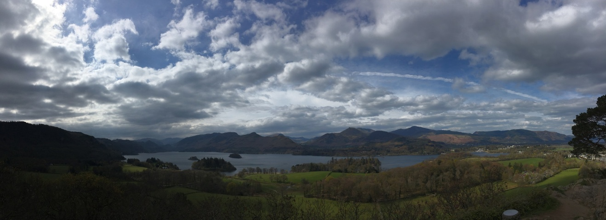

Derwentwater from Castle Head

Monday 15: Low Fell - 6 miles + 1300’: Very windy, cool & cloudy, dry

We drove to Loweswater and met up with Roger & Ann Hiley and their two dogs (see their website for photos at: http://www.loweswatercam.co.uk)

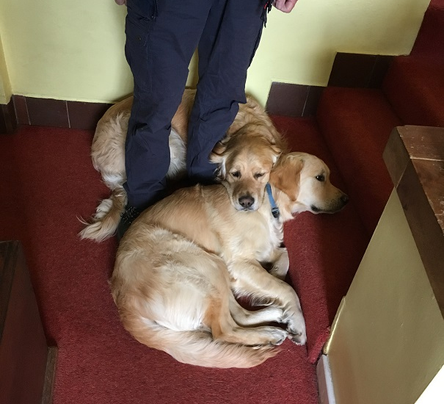

Dylan & Dougal making me feel at home after 2 minutes!

We had a lift to Thackthwaite and walked up Low Fell. It was blowing a gale, but we made the southern summit OK. We returned eastwards down part of that steep hillside, but soon branched off south and contoured round to the Lonesome Pine tree. A tasty lunch was had at the Kirkstile Inn.

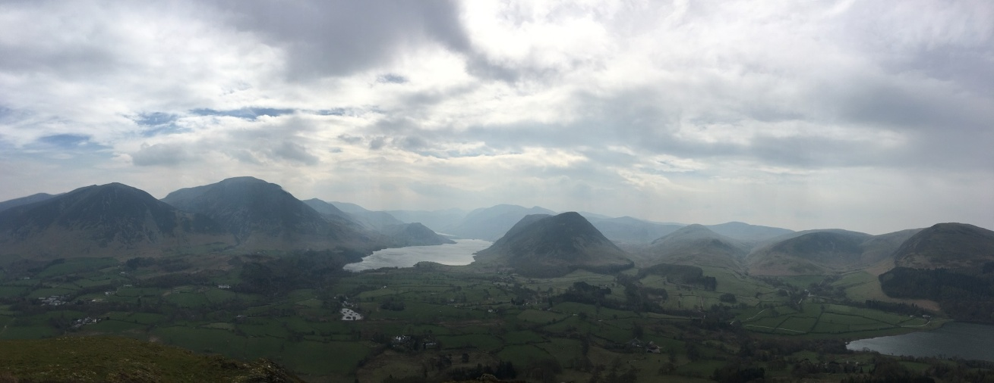

Crummock Water from Low Fell

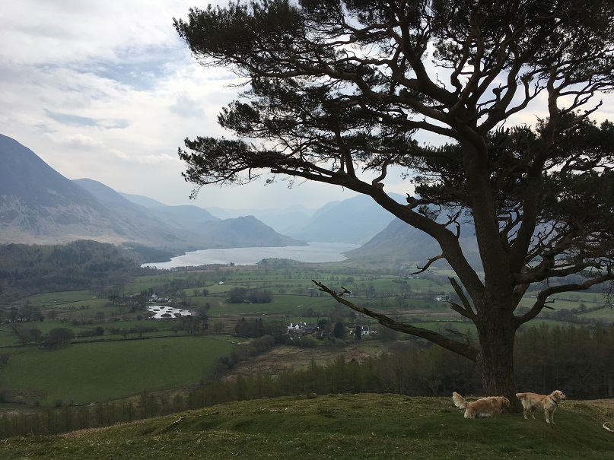

Crummock Water from the Lonesome Pine on Low Fell

Tuesday 16: Latrigg – 7.25 miles + 1225’: Breezy, sunny intervals, hazy & dry

We walked from the bungalow to the old railway station and up Spooney Lane to the summit. Then east down the ridge to Brundholme and sharp south-west to have our lunch in the shelter of some young trees.

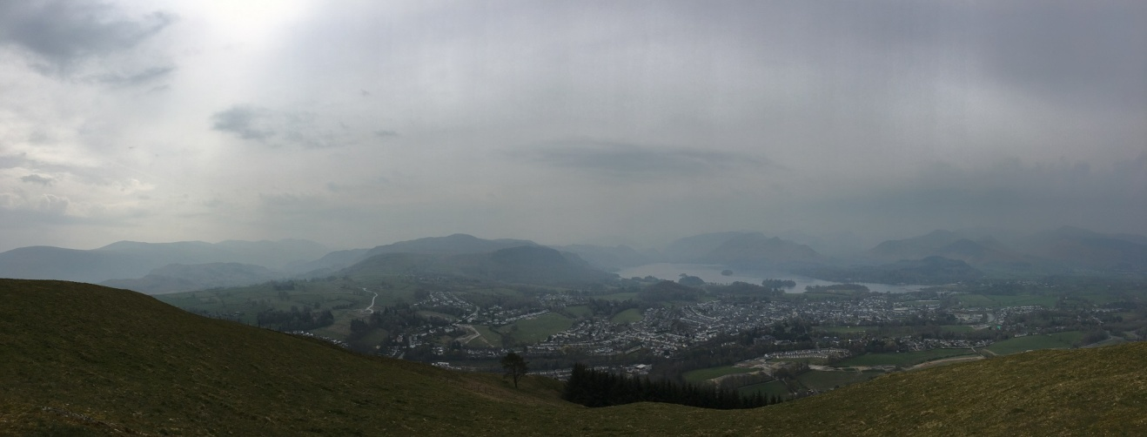

Keswick from Latrigg

Wednesday 17: King’s How – 5 miles + 1500’: Warm, sunny, clear & dry

We drove to the car park close to Grange and walked up Troutdale. Lovely climb through the wood to the summit. Then down south to the road, missing the awkward path we went up last October and back via the Bowder Stone. Tea and scones in the roadside café in Grange (the riverside one was closed).

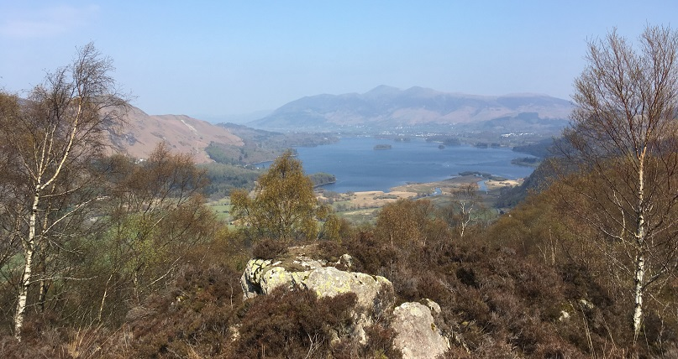

Derwentwater from King’s How

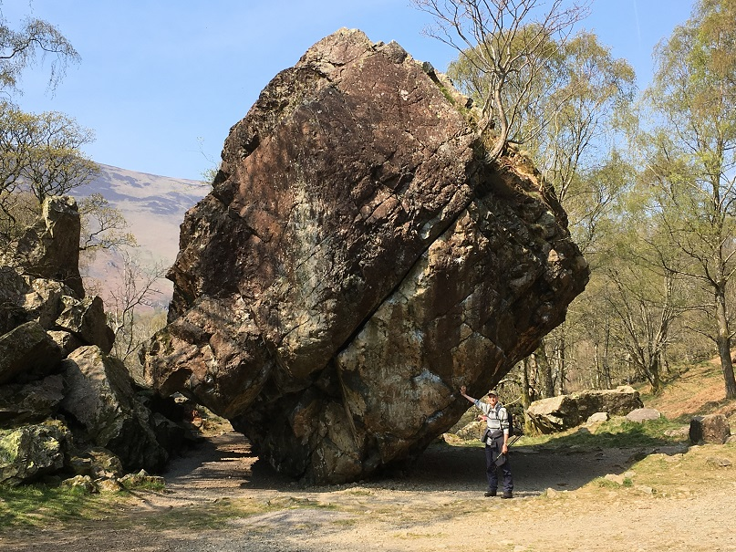

Bowder Stone (without step ladder - being replaced)

Thursday 18: Rest day – 4 miles: warm, sunny & dry

Stroll from the Bungalow to Friar’s Crag & round Keswick via Isthmus Bay.

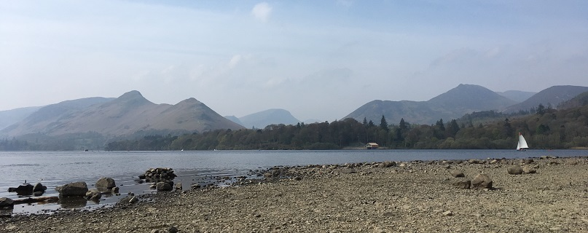

NW Fells from Isthmus Bay

Friday 19: Cat Bells – 6 miles + 1500’: fine, warm, sunny, clear & dry

We drove to the car park at the southern end of the ridge by 8.40am and walked up to the summit. Rich had to give me a push up the rocky bit near the top! Excellent clear views.

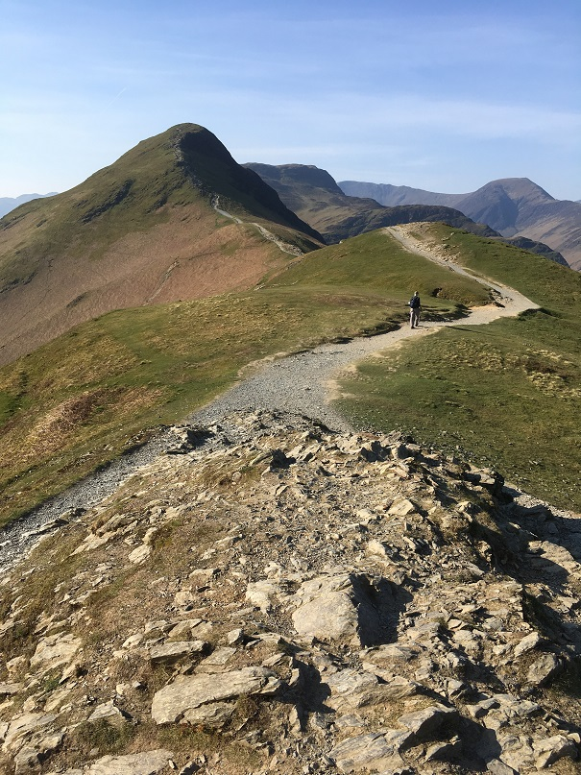

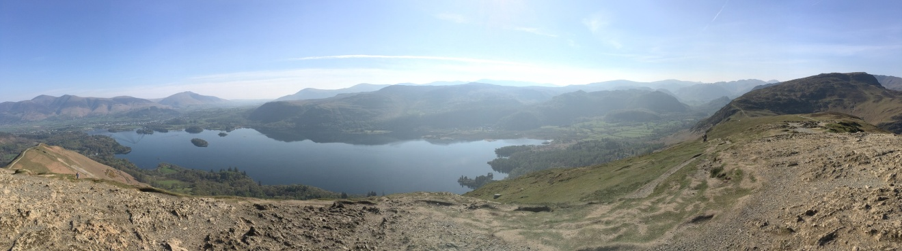

Derwentwater from Cat Bells summit

Then down from the Hause and back along the lakeside. Lunch on a picnic table in Brandelhow Bay.

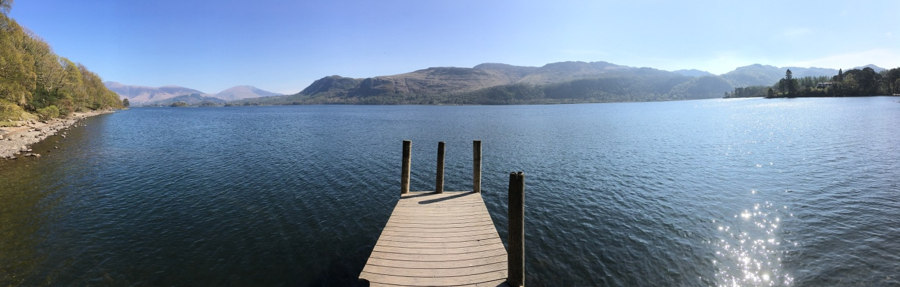

Skiddaw Range from Brandelhow Bay

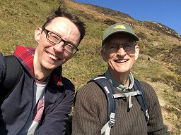

Thanks to Richard for a lovely week!

